**[How to interface Stepper Motor with PIC18F4550 Microcontroller](http://www.engineersgarage.com/embedded/pic-microcontroller-projects/interface-stepper-motor-circuit" \o "How to interface Stepper Motor with PIC18F4550 Microcontroller)**

A [Stepper Motor](http://www.engineersgarage.com/articles/stepper-motors) is a brushless, synchronous DC motor which divides a full rotation into a number of steps. For detailed information on working, types and stepping modes, refer the article on [Stepper Motors](http://www.engineersgarage.com/articles/stepper-motors). Here the operation of a unipolar Stepper motor with [PIC18F4550](http://www.engineersgarage.com/electronic-components/pic18f4550-microcontroller) microcontroller has been explained.

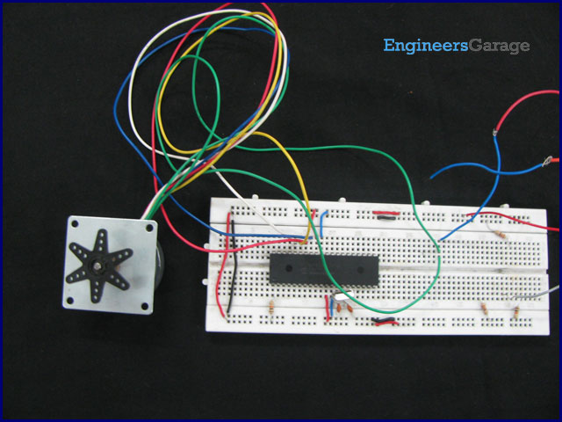

As stated earlier, a [Stepper motor](http://www.engineersgarage.com/articles/stepper-motors) rotates step by step. Each stepper motor has a defined step angle which is the minimum degree of rotation in a single step. This step angle depends on the internal construction of the motor. If a stepper motor has a step angle of 1.8°, then it would need 200 steps for a complete circular rotation. For control operation, construction and stepping modes, refer the article on [Stepper Motors](http://www.engineersgarage.com/articles/stepper-motors).

The stepper motor consists of a Rotor and four Stators. The stators are rounded with center-taped winding. The center-taped terminals are known Common terminals. Thus a unipolar stepper motor consists of total 6 wire-ends (four wires for coils and two for the common ends).

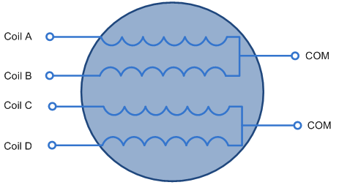

The COMs are connected with +12V which is the power supply to drive the stepper motor. To rotate the Rotor, zero voltage is provided at coil-ends one by one in a sequential manner. (Based on this sequence, stepper motors have different stepping modes which are explained in the article on [Stepper Motor](http://www.engineersgarage.com/articles/stepper-motors))

The sequential voltage signals are provided by the [PIC microcontroller](http://www.engineersgarage.com/articles/pic-microcontroller-tutorial). A repetitive sequence of 1110, 1101, 1011 and 0111 is sent by [PIC18F4550](http://www.engineersgarage.com/electronic-components/pic18f4550-microcontroller) to its PortB pins to rotate the Stepper motor.

Although this PIC microcontroller can provide enough output current to drive the stepper motor, but its becomes more efficient by employing a current driver between the controller and motor. For this purpose, sometimes ULN2003 is used to drive the stepper motor. Check [interfacing Stepper motor with 8051 using ULN2003](http://www.engineersgarage.com/microcontroller/8051projects/stepper-motor-control-ULN2003-at89c51-project-code-circuit) for reference.

**// Program to Interface Stepper Motor with PIC18F4550 Microcontroller**void main()  
{  
 unsigned int i=0;  
 TRISB=0; // Set PortB as output port  
 while(1)  
 {  
 LATB=0x07; // To send 1110 at PortB  
 Delay_ms(20);  
   
 LATB=0x0B; // To send 1101 at PortB  
 Delay_ms(20);  
   
 LATB=0x0D; // To send 1011 at PortB  
 Delay_ms(20);  
   
 LATB=0x0E; // To send 0111 at PortB  
 Delay_ms(20);  
 }  
}

